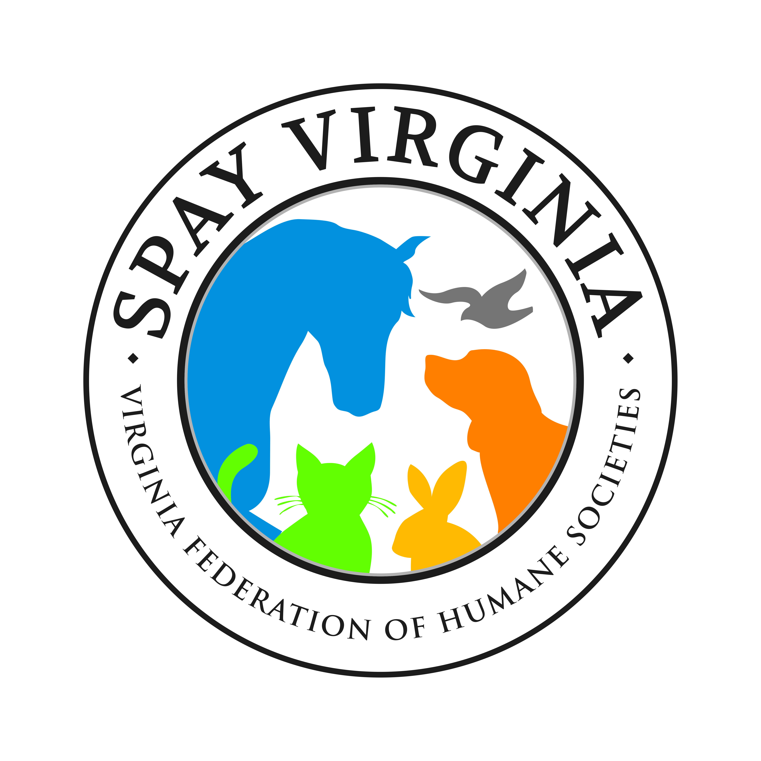
Spay/Neuter Grant Application 2020

The goal of SpayVA Grants is to reduce shelter intake and euthanasia by funding local spay/neuter efforts. Overall priority is given to applicants who serve under-performing/under-resourced areas of the state. Additionally, applications from previous award recipients will be scored based upon the applicant’s history of complying with grant requirements, such as timely reporting.

Name of Organization
Mailing Address
City County Zip Code
Grant Contact Title
Phone Number Email Address
Website:
NOTE: Please ensure organization’s website is current as grant reviewers will be utilizing it to find out information about your organization.
In (year) your total revenue $ and total expenses $
Estimate how work is done % by volunteers; % by paid personnel
Amount requested:
(Maximum award amount varies and organization will need to adhere to spay/neuter maximum amount of $50.00/cat and $100.00/dog)
If awarded, would this grant be used to fund a current spay/neuter program or a new program? Please give program name and a brief description:
New Existing
Does your organization currently have a low-cost spay/neuter program?
If so, how many spay/neuter surgeries were performed through this program last year?
Does your organization have a TNR program?
What cities/counties in Virginia will your program serve?
Will this program target: (Please select all that apply)
Pit bulls Hounds Feral/community cats
Owned cats Owned dogs Other: please explain
Where will the surgeries be performed?
Will you partner with any other organizations?
If yes, please provide the names of your partner agencies and briefly describe the nature of your collaboration.

Please attach the following:
Organization’s IRS 501(c)(3) determination letter, if applicable.
Current fiscal year operating budget
Note: most recent 990 (detailed 990; not just the postcard) may be requested – but not required to be attached.
This application, along with all required documents must be sent (single email) to info@spayva.org no later than March 15, 2020, 5:00 pm.
Grant recipients will be notified by March 20th if they were awarded funding and will receive their check at the VFHS conference in April.

